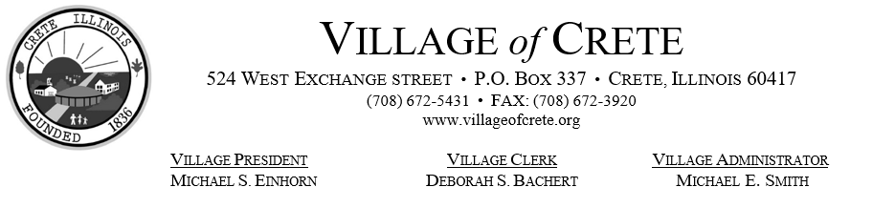

AGENDA
VILLAGE OF CRETE
PRESIDENT AND BOARD OF TRUSTEES MEETING
April 10, 2023

REGULAR BOARD MEETING:
Date: April 10th, 2023
Call to Order: 7 p.m.
Village of Crete Municipal Building
Pledge of Allegiance
Roll Call

CITIZENS SPEAK:
Visitors are always welcome to all public meetings of the President and Board of Trustees of the Village of Crete. Interested parties wishing to speak should identify their intent to speak, they then may give their name and where they reside if they so choose and then make their comment. Persons may also provide their address privately to the Village Clerk if they so choose; persons are advised that addresses are considered private information under the Freedom of Information Act and thus are exempt from disclosure pursuant to any Freedom of Information Act request. However, in order to give proper consideration to all items on the agenda, the President has the authority to limit participants in debates and will close repetitive or abusive remarks. In addition, public comment rules are posted in the board room.

APPROVAL OF AGENDA:
Special orders:

UNANIMOUS CONSENT AGENDA

All items on the Consent Agenda are considered to be routine in nature and will be enacted in one motion. There will be no separate discussion of these items unless a board member so requests, in which event, the item will be removed from the Consent Agenda and will be considered separately.

- Approval of Minutes : Regular Board Meeting – March 27th, 2023
- Approval of Bills March 24, 2023 thru April 7th, 2023
- Ratification of Payroll - Bi-weekly payroll ending April 5, 2023

REPORTS: PRESIDENT AND TRUSTEES:
Public Health – Trustee Katrina Seifert
Water Department – Trustee Stephen Johnson
Road and Bridge – Trustee Steve Bruns
Building and Grounds – Trustee John Phelan
Finance, License and Ordinance – Trustee Mark Wiater
Public Safety – Trustee Holly Milburn
President Michael Einhorn –

COMMITTEE AND DEPARTMENT REPORTS:
Village Administrator – Michael Smith
Police Department – Chief of Police Scott Pieritz –
Fire Department – Chief James Muirhead
Superintendent of Public Works – Justin Pancrazio – Report submitted
Building Department – Building Inspector Mike Smith – Report submitted
Code Enforcement – Code Enforcement Supervisor Marty Braccio
Fire & Police Commission – Jim McPhee
EMA – Marty Braccio
Animal Control/Code Enforcement Officer – Ryan Allison
Planning Commission – Karen Tellef
Heritage & Architecture Commission – Phyllis Monks
Media Consultant – Nick Borrell

COMMUNICATIONS:

Warrants:
Excise (Telecom. Tax) – (Col. Jan) 2023-$ 7,639.38 2022-$ 8,989.63
Local Use – (Col. March) 2023-$38,795.55 2022-$38,503.06
Sales Tax – (Col.) 2023-$ 2022-$
Sales Tax of ½ percent – (Col.) 2023-$ 2022-$
Income Tax – (Col. March) 2023-$73,777.37 2022-$62,335.65
MFT Allotment – (Col.) 2023-$ 2022-$
Pers. Prop. Rep. Tax–(Col.) 2023-$ 2022-$
ComEd Utility Tax (Col. Feb.) 2023-$25,451.85 2022-$26,597.56
Nicor Utility Tax (Col. March) 2023-$32,251.68 2022-$36,839.19
Video Gaming Report (Col. March) 2023-$26,519.89 2022-$22,389.31

OLD BUSINESS:

NEW BUSINESS:
- Inquiry received from Michael Waddington concerning the purchase of the vacant lot at Aberdeen Drive and St. Andrews Drive (formerly 499 Aberdeen Drive). Plans to have lot remain vacant but maintain as needed to improve looks. Board action may be taken.
- Resolution 2023- : A Resolution requesting the Village of Crete Memorial Day Parade to take place on Illinois Route #1 on Monday, May 29th, 2023 from 11:30 a.m. until 1:30 p.m. Board action is anticipated.

EXECUTIVE SESSION:

ADJOURNMENT:

NEXT MEETING ACTIVITY: The next regular Village Board Meeting will be held at the Municipal Building on April 24, 2023 at 7:00 p.m.

Other Meeting Activity: Police Pension Fund will meet on Wednesday, April 12th, 2023 at 4 pm at the Municipal Building, 524 W Exchange Street.

Pursuant to the open meetings act, this notice had been posted in the window of the Village Clerk’s office 48 hours prior to the meeting. No new or additional business to act upon may be added to this agenda.

Posted April 7th, 2023 – Deborah S. Bachert, Village Clerk

